First Baptist Church Varnville
December 22, 2024
Rev. Dr. Thomas Kelly, Jr., Pastor
Mrs. Annette Tuten, Minister of Music
Mr. & Mrs. Chip Mixon, Directors of Praise & Worship
Morning Worship – 11:00 A.M.



Prelude

Chiming of the Hour

Call to Worship “Let All Mortal Flesh Keep Silence” (178) Choir

Invocation

Hymn # 199 “O Come, O Ye Faithful”

Welcome & Announcements

Hymn # 179 “Angels, from the Realms of Glory”

Offertory Prayer

Doxology

Lottie Moon Christmas Offering Video

Children's Sermon

Special Music “Beautiful Star of Bethlehem” Choir

Scripture (Pew Bible Pages 724-725) Luke 2:1-20

Message “God's Rescue Plan” Rev. Dr. Tommy Kelly

Invitation Hymn # 313 “Take the Name of Jesus with You”

Benediction

Deacon on Call Lee Mixson (843-812-1215)
Ushers for December Kenneth Corbin and Wade Ferguson
Teller Gwen Heape

Attendance Last Sunday: Sun. School -84 Early Service -95 11:00 Service -48

Opportunities of the Week:
Sun: 5:30 Life Recovery in the Life Center
Tues: 6:00 Christmas Eve Candlelight Service
Wed: Merry Christmas! (No Wednesday Services)

Our Finances for 2024-2025: Homebound of the Week
Bdgt. For 2024-2025: $510,622.31 Jo Ann Williams
Bdgt. Needs for Week: 9,819.66 PO Box 211
Rcvd. Last Sunday: 8,931.00 Varnville, SC 29944
Bdgt. Needs to Date: 157,114.56
Rcvd. To Date: 144,510.85

Lottie Moon Christmas Offering Goal: $5,000.00. Received to Date: $2,363.25
Our Lottie Moon Post Office is open. The cost is 25 cents per card.

Playground Equipment Goal: $97,863.00 ∼ Received to Date: 10,533.41
Seminary Scholarship Received to Date: $9,830.00

We are still accepting donations for Tommy's Projects,
Playground Equipment and the Seminary Scholarship.


If you would like to place flowers in the church on a specific date in 2025, please sign up on the new flower calendar in the vestibule. We will need to move the sign-up sheet in the next few weeks for early service members to have an opportunity.


A daily devotional book written by local pastors is available in the church office. This book includes a daily devotional reading for all 2025. Cost for each book is $10.00. Any profit collected from this devotional book sale will go toward mission projects within the local area.


A love offering will be taken up next Sunday morning, December 29th, in the combined worship service for Neal Winn. Neal lost everything this past week due to a house fire.



December 24th ∼ 6:00pm

“God's Rescue Plan”
Luke 2:1-20

Introduction: _________ gives the most ___________ look at the ____________ of the ______________ _____________________.

Over many years, ________________ commonly associated with __________ have seeped into the _________ of Christ's ________.

__________ __________ is really the ___________ ____________ __________ __________________.

____________ reports the ____________ that fulfills __________ _________________ _________________.

I. The __________ In _____________ ________________ (v. 1-7)

II. The __________________ ______________________ (v. 8-12)

III. The _____________ As ______________________ (v. 13-20)

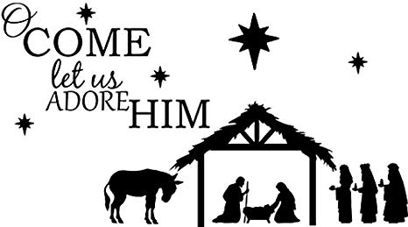

May the miracle of that first Christmas renew your heart with JOY
Merry Christmas from your Church Staff!

First Baptist Church

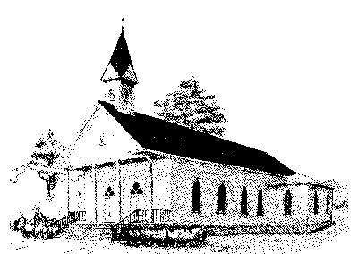

Early Morning Worship 8:30 am
Sunday School 10:00 am
Morning Worship 11:00 am
Wednesday Night Services 6:15 pm

P. O. Box 306- Phone 803-943-3089
165 Palmetto Ave.
Varnville, SC 29944

Website: www.varnvillefbc.com
Email: varnvillefbc@lowcountry.com

Enter to Worship…......Go Forth to Serve

