Opportunities for January

Jan. 1 Happy New Year!

Jan. 8 5:30 Supper Resumes

Jan. 8 6:00 AWANA Resumes
Jan. 12 12:15 Staff Lunch/Mtg.

Jan. 12 2:00 Deacon's Meeting

Jan. 13 10:30 Pat Connelly Missions
Jan . 15 6:15 Business/Prayer Mtg.

Jan. 20 7:00 Brotherhood Meeting
Jan. 21 Newsletter Articles Due

Ushers for January
Larry Helms
Hal Horton

Tellers for January
January 6 Gwen Heape
January 13 Sheron Barnes
January 21 Gwen Heape
January 27 Sheron Barnes

Deacons on call for January

Bill Parker (Dec. 29 - Jan. 4)

DeKelly Pittinger (January 5-11)

Mike Poston January 12-18)

Randy Vaughn (January 19-25)

Robert Brown (Jan. 26-Feb.1)

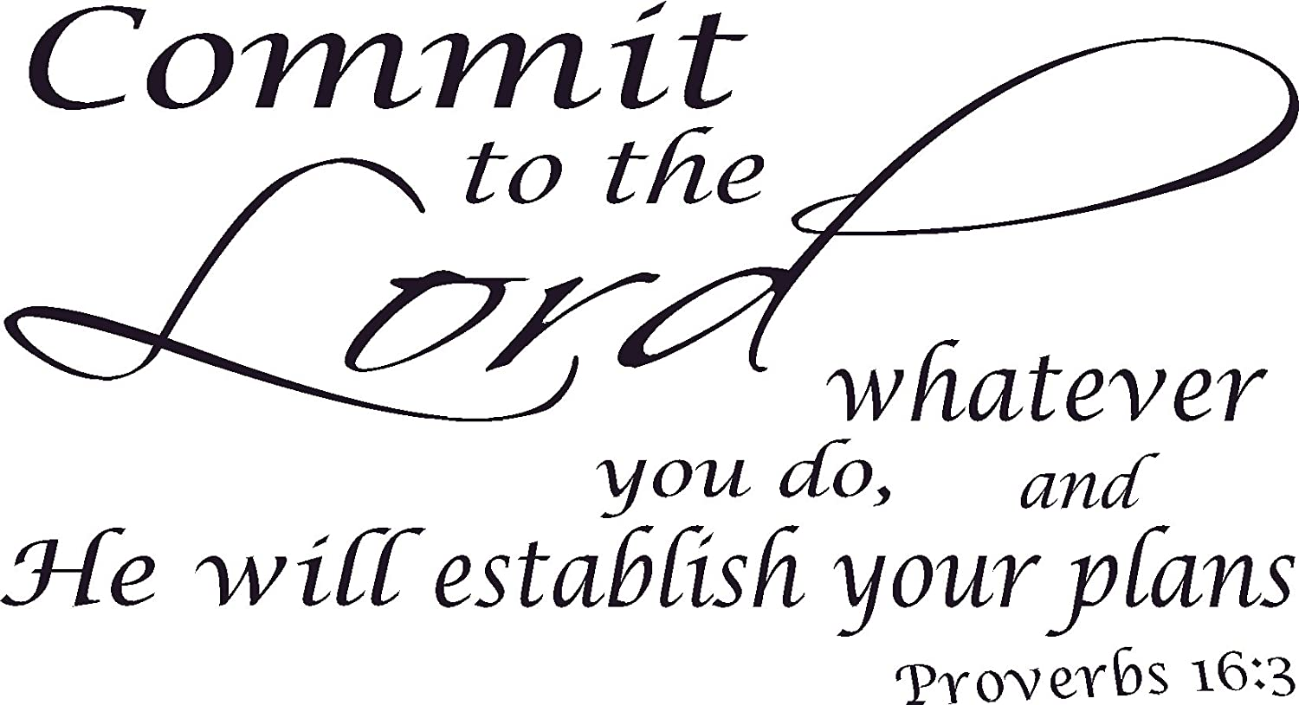


Varnville First Baptist Church, Inc.

Volume 37 Number 1 2025





January Bible Study

Beginning January 8th

The Faithfulness of God



Wednesday, January 8th at 6:00pm


Starting Over Again

Since 2025 will start in a few days, it is profitable to reflect upon the accomplishments and events of 2024. Reflection can help a person or organization understand their characteristics and trends. From this exercise, any individual or entity can manage their tendencies and behaviors better. Paul called the early Christians to engage in such a practice by stating, "But be ye transformed by the renewing of your mind" (Romans 12:2a).

One positive reflection of 2024 would be Camp Bridge Builders. Upon reexamination of this summer camp, the deacons and staff understood this camp was a positive experience for the church, the community as well as Grace Church. Therefore, meetings with Grace Church have been taking place in order to plan for Summer 2025 camp. The hospitality conveyed upon Grace Church staff and volunteers was extremely positive. Varnville First Baptist embraced this camp which demonstrates a great love for Christ and the surrounding communities.

Please continue to pray for Varnville First Baptist Church children and youth programs. AWANA and children's church are continuing to meet. The Children and Youth Committee's are meeting monthly to plan activities that are children and youth focused, as well as family friendly. The deacons are reconstructing as well as reevaluating the Minister of Children/Youth job description. Please continue to pray for this important ministry.

Each new year presents different opportunities and challenges. Also, God promises to walk with and guide His followers. Therefore, it is important for all believers to demonstrate God's faithfulness to a lost world. May all Varnville First Baptist Church family members model Christian faith throughout the new year.
In Christ,
Tommy



VFBC Brotherhood
Will meet in the Social Hall
Monday, January 20th at 7:00pm

The New Year
Poet: C. E. Lund
Outmarching time, with rapid stride,
Like onward flow of ebbing tide,
Has carried forth the closing year,
And hailed the new one to appear.
As at its threshold now we stand,
May each extend a helping hand;
And ever aid, in word and deed,
The sad and suffering in their need.
We know not what this year may bring,
But at its advent we will sing,
that higher aims may fill our hearts,
As day by day the year departs.
If joy shall smile upon our way,
And we are spared to longer stay,
May we reflect that joyful smile
And keep our lives devoid of guile.
Should sorrow, sadness, sickness, death,
Becloud our lives and still our breath;
May hope increasing, brighter grow,
That we no sting of death may know.
Our motto for this day shall be,
"Let peace and love abide in me,
And may we help each other bear
The ills that come throughout the year."



Pat Connelly Missions Group
Will meet in the Social Hall
Monday, January 13th at 10:30 AM



If you would like to place flowers in the Church and the Life Center on a specific date in 2025, please sign up on the new flower calendar. We will rotate the list throughout the year between the
Sanctuary and the Life Center.



Please submit your articles for the February Newsletter to the church office no later than Tuesday, January 21st.



6

January 3 Becky Ginn
January 3 Priscilla Schaffer
January 4 Bobbie Brunson
January 5 Kayla Stanley
January 7 Rita Davis
January 8 Ashton Blocker
January 11 Victoria Drawdy
January 11 Tabitha Noll
January 12 Bryan Breland
January 12 Alton Smith
January 14 Todd Litchfield
January 15 Patricia Williams
January 20 Christopher Mills
January 21 Gerald Ulmer
January 22 Liz Hager
January 22 Jacob Stanley
January 22 JoAnn Williams
January 24 Kyle Mitchell
January 24 Mark Paden
January 24 Perry Padgett
January 25 Lisa Cope
January 28 Don Cope
January 29 Sally Ellis
January 29 Claudia Long
January 30 Wyman Breland
January 30 Ronnie Gray
January 30 Kelli Mixon
January 31 Wade Freeman
January 31 Hal Horton

JANUARY BIRTHDAYS

\



